**PROTOCOL FOR TRIAL PROCEDURE**

The patient will arrive in the Interventional / Operative Suite having been recruited to the trial, with the Study Consent Form signed, and the appropriate DEB Trial equipment and staff present. If for some reason the DEB Trial cannot proceed for this patient at this stage (eg the AVF is found to have occluded), “Form for Study Patients Who Are Not Randomised” must be completed. This only applies if the patient is permanently removed from the trial; if the Trial Procedure is only delayed, no specific action needs to be taken.

1. **Standard Fistula Intervention Protocol**

* A standard “Marker Grid” must be placed under the Index Trial Area.
* The Index Lesion in the fistula will then be treated with the Standard Fistula Intervention.
* During the Standard Fistula Intervention, a Trial Index Stenosis With Marker Catheter Angiogram should be performed with a **size known catheter and / or sheath in the image**. An image of this angiogram - should be attached to the Operative Report for DEB Trial. The French size of the catheter / sheath in the image is should be clearly marked on the image.
* On satisfactory completion of the Standard Fistula Intervention, the patient will be randomised to the Study Group or the Control Group using the Randomisation Protocol. Randomisation is effected by ringing Westmead Hospital and contacting the “on duty” randomiser:

**Kirsty**: 9845 7680 or 0429 633809 or 0403 620235

**Kerry**: 9845 6412 or 0431 123144

If for some reason the DEB Trial cannot proceed at this stage (eg it was not possible to cross the stenosis and treat the lesion), a Form For Study Patients Who Are Not Randomised must be completed.

**2.Trial Balloon Protocol**

The DEB must be done strictly to protocol as detailed below. Violations of DEB Application Protocol must be reported on the Operative Report for DEB Trial.

Note: The Trial Balloon must have a bigger diameter than the final diameter of the Treated Area. The Trial Balloon must therefore be 0.5 to 1mm bigger than the biggest balloon used during the Standard Fistula Intervention. The largest DEB is 7mm at Nominal Pressure, but 7.59mm at Rated Burst Pressure. Therefore the largest permissible Balloon in the Standard Fistula Intervention is 7mm blown up to Nominal Pressure.

2a. Trial Balloon: DEB

* Careful removal of DEB from the packaging and removal of the metal stylette from the tip of the balloon catheter without disturbing the red Balloon Protector Sheath.
* Do not prep the balloon, Do not prep the balloon channel and do not prep the wire channel! Prep the balloon channel once the balloon is in deployment position immediately before inflation.
* Trim back 3mm the flared end of the Balloon Protector Sheath with a scalpel blade after retreating the DEB within the sheath by 3mm. This is to allow the Balloon Protector Sheath to engage and defeat the valve in the Fistula Access Sheath.
* The DEB should be introduced into the sheath and inflated at the Index Trial Area with minimum delay. The FIRST timer is switched on when the balloon is fully in the access sheath and runs until the balloon is fully deployed to measure DEB Access Time. This time should be recorded on the Operative Report for DEB Trial.
* The DEB should be inflated between Nominal Pressure and Rated Pressure. Maximum Pressure should be recorded on the Operative Report for DEB Trial.
* The SECOND timer is switched on when the balloon is fully inflated to desired pressure and runs until the balloon is deflated; this time should be recorded on the Operative Report for DEB Trial as the Duration Of Trial Balloon Inflation.
* Acquire an X-ray image of the Index Trial Area with the Trial Balloon fully inflated, with a sheath +/or catheter in the image. This image - the Trial Balloon Xray Image - should be attached to the Operative Report for DEB Trial. It should be marked on the image what the French size of the catheter / sheath in the image is.

2b. Trial Balloon: SHAM

* Should be prepped and deployed as above **ie same protocol as DEB,** including the inflation times, recording of times etc.
* There are only 2 differences between the DEB and SHAM balloon. 1. One is drug coated, the other is not. 2. The DEB is 2 cm longer than the SHAM balloon. The SHAM balloon is applied to the whole Treated Area only. The DEB is applied to the whole Treated Area +1cm on either side. (Fig3)

**3. Completion Angiogram:** When the application of the Trial Balloon is completed, a completion angiogram should be performed with a **size known catheter and / or sheath in the image**. An image of this angiogram - should be attached to the Operative Report for DEB Trial. The French size of the catheter / sheath in the image is should be clearly marked on the image.

**4. Operative Report for DEB Trial**

This should include:

1. Standard Operative Report
2. Operative Report for DEB Trial
3. Diagram drawn on Standard Fistula Template by the Trial Balloon Operator of the Index Trial Area.
4. Printed image of the Trial Index Stenosis With Marker Catheter Angiogram
5. Printed image of the fully inflated Trial Balloon Xray Image.
6. Printed image of the Completion Angiography.

Vs10 12/05/2015

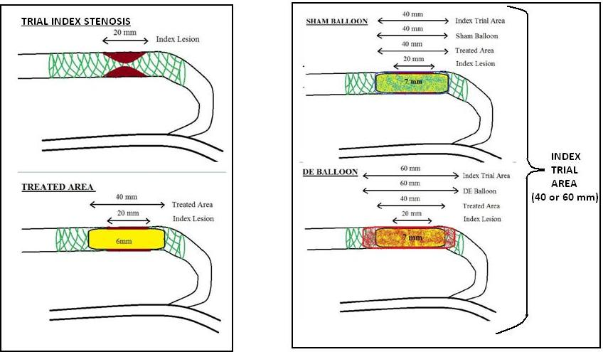

**Figure 3:** The difference in length between DEB Trial Baloon and Sham Trial Balloon