

**St. Vincent’s SportsMed**

**Measuring the effect of Hyaluronic acid (HA)on tendon healing after arthroscopic rotator cuff repair: A prospective randomized clinical trial**

**3rd check point**

**3 months post op**

**(Patient part)**

Patient Name: _________________________________________________________

Age:

sex: M F

Hand dominance: R L

Operative shoulder: R L

Investigator: Signature:

Date:

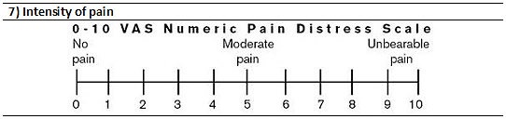**ASES score (patient section) 1**

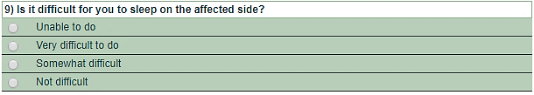

1.American Shoulder and Elbow Surgeons Standardized Shoulder Assessment Form, patient self-report section: reliability, validity, and responsiveness.Michener LA, McClure PW, Sennett BJ.J Shoulder Elbow Surg. 2002 Nov-Dec;11(6):587-94.



**Constant shoulder score 2**

**(Patient part)**



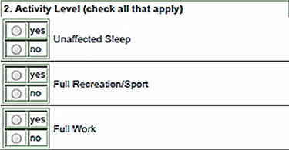

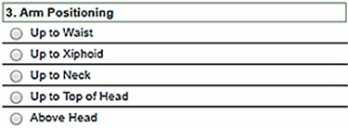

2.Constant CR, Murley AH. A clinical method of functional assessment of the shoulder. Clin Orthop Relat Res. 1987 Jan;(214):160-4 {adopted by The [European Society for Shoulder and Elbow Surgery (ESSES)](http://www.secec.org/)**}**



**St. Vincent’s SportsMed**

**Measuring the effect of Hyaluronic acid (HA)on tendon healing after arthroscopic rotator cuff repair: A prospective randomized clinical trial**

**3rd check point**

**3 months post op**

**(Physician part)**

Patient Name: _________________________________________________________

Age:

sex: M F

Hand dominance: R L

Operative shoulder: R L

Investigator: Signature:

Date:

**Please document any adverse events in the adverse events form**

**Constant shoulder score**

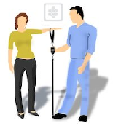**(Physician part)**

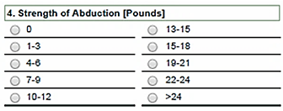

**Strength is measured using a spring balance**

|  |  |  |
| --- | --- | --- |
| **MRC grade:** 0 = No contraction, 1= flicker, 2=Movement with gravity eliminated  3= Movement against gravity, 4=Movement against some resistance, 5= Normal power | | |
|  | Right | left |
| Forward elevation | 0 1 2 3 4 5 | 0 1 2 3 4 5 |
| Abduction | 0 1 2 3 4 5 | 0 1 2 3 4 5 |
| External rotation (Arm at side) | 0 1 2 3 4 5 | 0 1 2 3 4 5 |
| Internal rotation (Arm at side) | 0 1 2 3 4 5 | 0 1 2 3 4 5 |

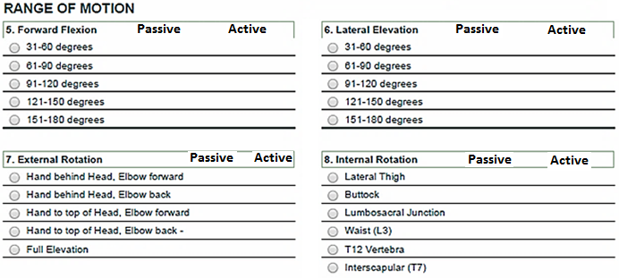

**Manual strength testing**